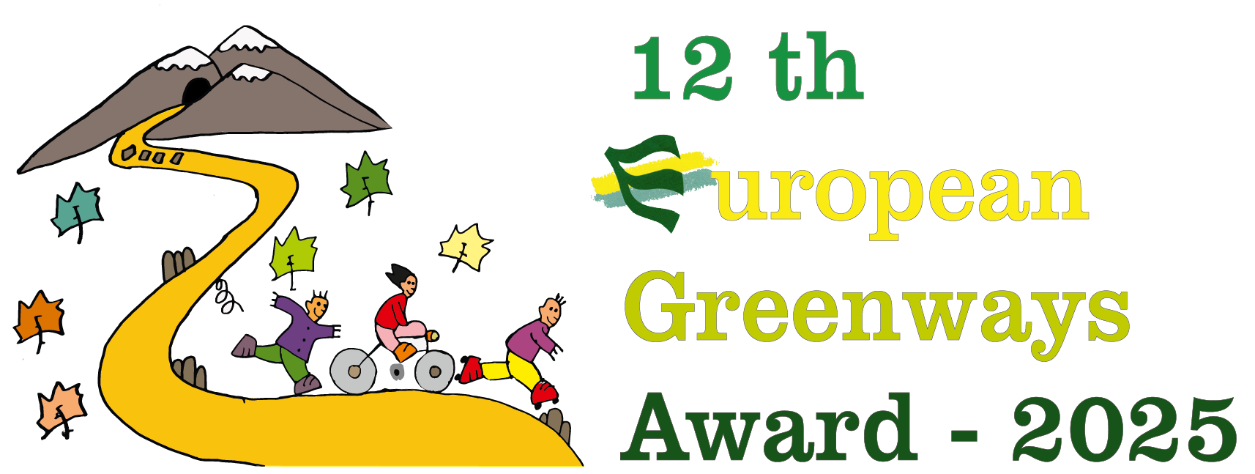 | APPLICATION FORM
12^{h} European Greenways Award

Exemplary initiatives category

1. General information

1.1 Candidacy
Name:

Short description (maximum 5 lines):

1.2 Details of applicant
Entity name (full legal name):

Abbreviated name
(if applicable):
Legal status:

Name and title of the person responsible for the technical aspects:
Name and title of the legal representative:
Address - Street & nº:
City:
Postal code:
Country:
e-mail:
Phone: (including international code):
Web site:
Social Networks

2. Description of the initiative

2.1 Where does your initiative take place?

Geographical situation (Country, region, town - please give as much detail as possible):

General characteristics of the greenway (to complete only if the initiative has been implemented on a specific greenway)

Greenway’s begin at:
Greenway’s end at:
Length: (km)
Width: (m)
Surface: (hard, smooth, pls indicate):
Average gradient: (%)
Towns and areas crossed:
Authorized users
(if possible, with estimation of user percentages, cycling, walking, wheeling):
Kind of usage
(leisure, tourism, daily trips, etc.)
(if possible, with estimation of user percentages):
Investment value and origin: (EUR)
Facilities offered to users of the greenway:
Type of previous use of the infrastructure (canals, railways):

2.2 Description of the implemented initiative

a) What are the aims of the initiative? (Maximum 5 lines)

b) Description of the implemented initiative. (Maximum 25 lines)

c) Dates & figures of implementation (schedule, date of completion of the works, date/period of activities, budget, employs, users …) (Maximum 20 lines)

d) What was the role of your organisation in this initiative? (Explain in 10 lines)

e) Please list all the other organisations involved and explain the role they played in this initiative

3. Why is your initiative exemplary?

3.1 Explain why this initiative is exemplary and its possibilities to be transferred. (Maximum ½ page)

3.2 Achievements & results of this initiative. Please include specific figures (from surveys counters, …) (Maximum ½ page)

3.4 Other relevant aspects (Maximum 10 lines)

4. Photo annex

A minimum of 10 and a maximum of 20 photos evidencing the initiative implemented must be submitted to illustrate the achievements of each candidate. Photos must be submitted with full copyright information and authorisation, and ready for web publication. (Photos must be at least of 300 ppp resolution and minimum size of 21cm x 15cm).

Photos must be sent electronically jointly with the application form to: award2025@aevv-egwa.org

The deadline ends on Thursday 29 May 2025 (New Deadline). Photos must be sent with clear reference of their candidacy

5. Map file of the greenway

A map of the greenway allowing clear location should be included in pdf format and a file in kml format or other standard format as gpx will be highly appreciated.

6. Supplementary information

The submission of other additional documents that could be helpful to evaluate your application is voluntary but highly appreciated: brochures, videos, guides, evaluation reports, web links… are especially welcomed; as well as the map file of the greenways, in .kml format, or any map in pdf, in case your application refers to an individual greenway, and can be sent in any language.

Supplementary information must be sent via e-mail using eventually a service for large file transfer to: award2025@aevv-egwa.org

Any supplementary information must be received by Thursday 29 May 2025 (New Deadline). at the latest to the address below.

7. Declaration of the applicant

Authorise EGWA to use information enclosed in this application in the preparation of documents associated with the Award and EGWA actions
Declare that I have read and accept the rules and terms of the Award
Certify that all the enclosed information is correct

Date :

Deadline for reception of the candidacies: Thursday 29 May 2025 (New Deadline).
e-mail: award2025@aevv-egwa.org

www.europeangreenwaysaward.org

